Lab 2: Containerization & Kubernetes Orchestration
Task 3: Containerization and orchestration report

1. Introduction
This report describes how a Flask web application was containerized with Docker and orchestrated on a local Kubernetes (Minikube) cluster.

2. Architecture
Dockerfile -> Docker image (lab2-python-app)
|
minikube image load
v
Minikube node -> Deployment (ReplicaSet, 2-5 pods) <- Service (NodePort 30080)

- Application: Flask app with / and /health endpoints (port 5000).
- Image: python:3.12-slim base, 7 layers, tagged 1.0 / 2.0 / 3.
- Cluster: single-node Minikube (Docker driver, Kubernetes v1.37.0).
- Deployment: 2 replicas, readiness probe on /health, RollingUpdate strategy.
- Service: NodePort 30080 -> container port 5000.
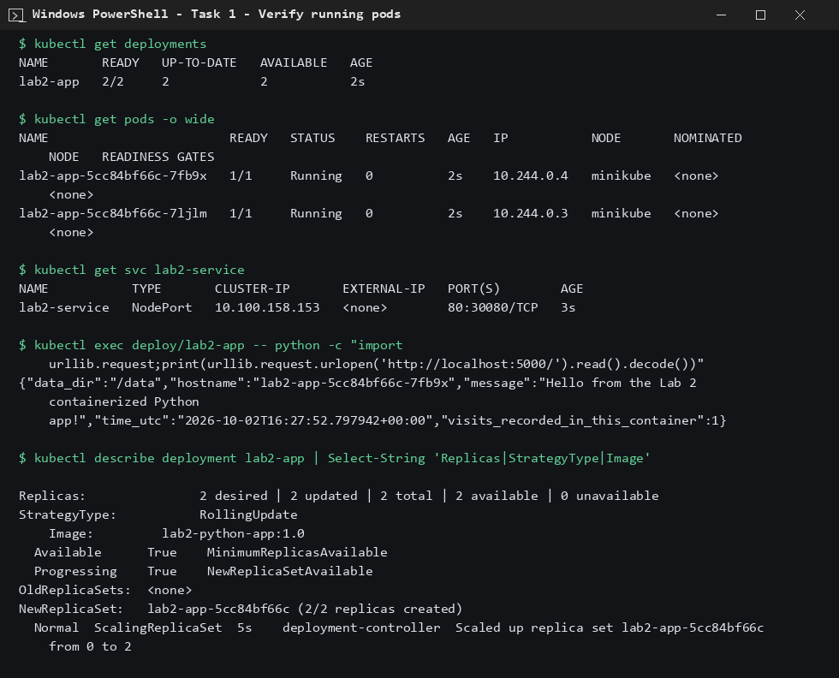
Figure 1: Running deployment, pods and service

3. Deployment strategy
RollingUpdate with maxSurge=1 and maxUnavailable=1: new pods start before old ones are removed, and the readiness probe keeps traffic away from pods that are not ready. A rollback uses the previous ReplicaSet.
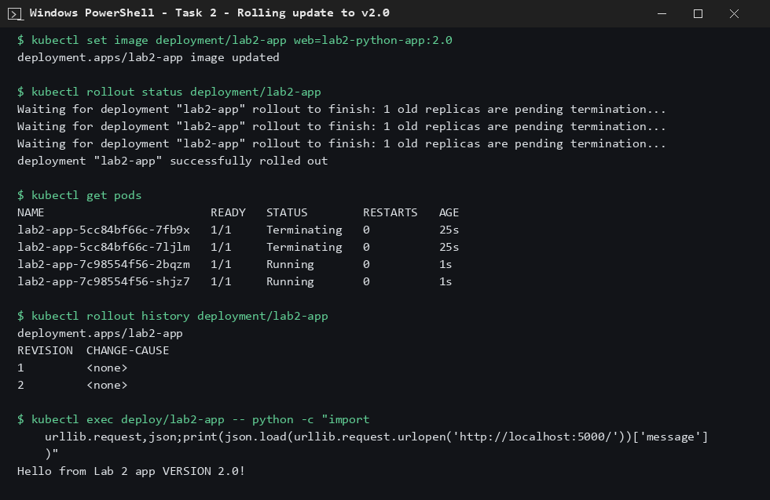
Figure 2: Rolling update from v1.0 to v2.0

4. Scaling results
Scaling from 3 to 5 replicas brought all new pods to Ready within about 15 seconds; scaling back to 3 removed the extra pods.
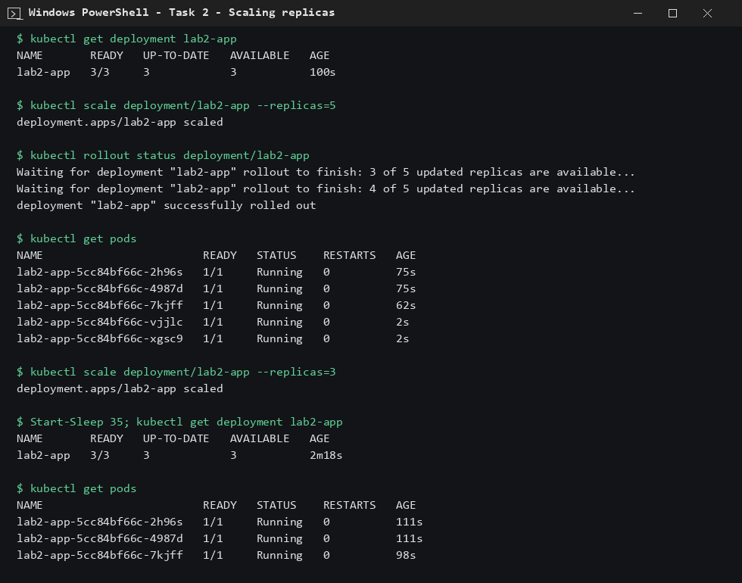
Figure 3: Scale up to 5 and down to 3

5. Observations
- Rolling update and rollback both completed successfully (rollout status confirmed).
- imagePullPolicy: Never is needed because the images exist only inside Minikube.
- Each pod has its own hostname and its own container-layer data, so state must not be stored inside pods.
- The CI/CD script re-applies the manifests and rolls out a new image automatically (see Task 8).
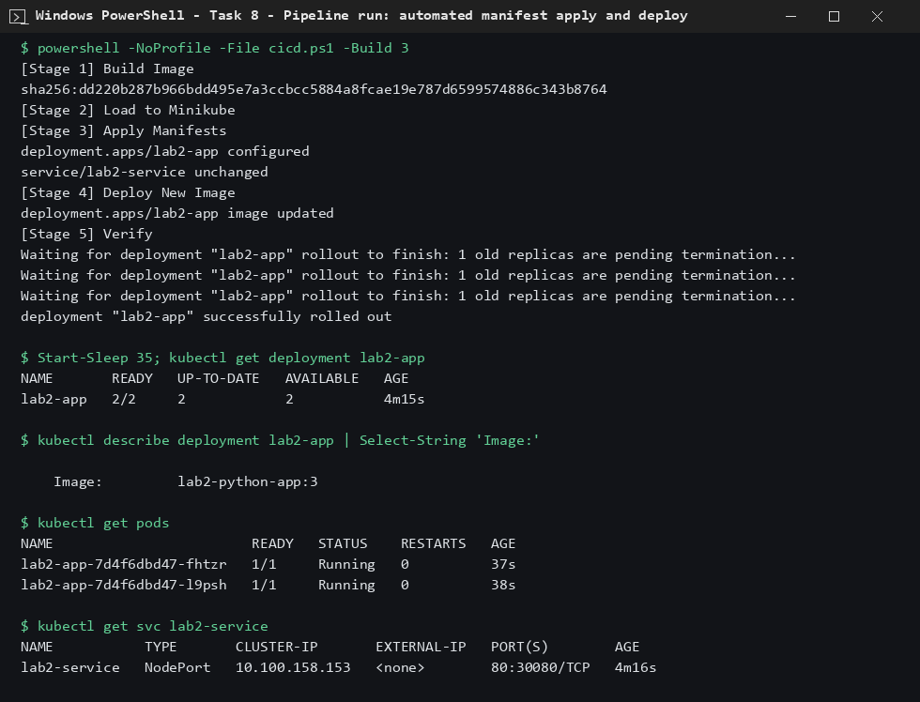
Figure 4: Automated deployment through the pipeline

6. Conclusion
The app was successfully containerized, deployed, updated, rolled back and scaled on Kubernetes.

